|  |  |
| --- | --- |
|  | **“GOOd For You”** |

**Team Members:**

**Mansi Padhiyar (0901509)**

**Jenab Vohra (0904905)**

**Jay Mangnani (0904910)**

**Nihal Gupta (0959636)**

**Kalyan Chintaguntla(0906298)**

**Submitted to:**

**Prof. Nancy**

**Introduction**

This document describes about the alternative’s deliverables with the aspect of the financial and non-financial variables. It includes the data which gives cost to calculate profit and the overall sales. This is also the journey of the process from beginning to the end with the high-level detail plan showing dates from start to end. The Gantt Chart is the way it describes the overall process. The three alternatives are as below:

1)Merger and Acquisition

2) Sole proprietorship

3)Marketing and Advertising

**1)Merger and Acquisition**

In this particular scenario we have try to discuss about the two concept that is merger and acquisition. In review to the merger there will partnership offered to the company owing the food truck and some of equipment. On the other side, the acquisition the business is acquired and then just share some of the profit with the old owner of the company.

**Purpose: Analysis on Merger& Acquisition effectiveness, grow more benefit while spending less, increase sales.**

The list of **variables** are divided into Financial and Non-Financial Variables: -

**Financial Variables:**

**1)Investment**: The prior amount spent to set a business.

* Merger: The investment will be decided according to the partnership decided by the mutual agreement with the other company who is also facing loss. We both will merge according to the share decided and investment respectively.
* Acquisition: The investment will be taking over company and then work towards change with the brand name. It will be more cost at the beginning but overall will save more time.

**2)Training:** It is the cost which will be one-time investment in the company in either case the training is needed to get into new system.

**3)Margin:** The margin is the profit percentage the company want at the end of the day. The margin will be set according to the share of investment in the company.

* Merger: The margin will be mutually decided and set accordingly. The share of the profit will be according to the investment made in the project.
* Acquisition: The margin will be decided mainly by the acquiring company and the profit is only taken by the acquiring company the other company is just paid for there things in form of salary.

**4)Licensing fee:** This fee is the money which you pay to government for selling the food with mobility, to roam all over the city freely and make business. From state to city the prices of them vary. This fees take more time that doing some other job. For the food truck it takes different time in both cases. The merger will take more time than acquisition.

**5)Equipment:** The extra cost in food truck business without which the business in not possible. It includes the truck, machines, pots, pans, inventory supplies. It will be almost equal cost.

**6)Parking fee:** This fees are paid monthly or daily basis and this will not change in any situation will be same as it needs to be.

**7)Operating cost:** The employees salary, gas, rewards, promoting all will be included in this section. In both situation the cost will work differently.

**8)Total Sales:** The sale which is done at the end of year and calculated monthly, weekly and daily basis to get the calculation for benefit, revenue and rate of interest.

**9)Scrape rate:** The amount of things wasted in whole day and keep track of things to get at the end of year the loss. The loss will be divided according to the investment.

**10)Overall Cost:** The cost which will acquire all the above mention variables in order to get the benefit from the either solution Merger or Acquisition.

**11)Benefit:** The total sales subtracting the overall cost in the whole year. It will generate ne profit.

|  |  |  |
| --- | --- | --- |
| **Financial Variables** | **Merger** | **Acquisition** |
| Investment | According to partnership | Invest in acquiring business |
| Training | One-time Investment | One-time Investment |
| Margin | According to partnership | Decide majorly by acquiring business |
| Licensing Fee | One-time Investment | One-time Investment |
| Equipment | One-time Investment | One-time Investment |
| Parking Fee | Regular Basis | Regular Basis |
| Operating Cost | Regular Basis | Regular Basis |
| Total Sales | Daily | Daily |
| Scrape Rate | Daily | Daily |
| Overall Cost | Daily | Daily |
| Benefit | Monthly | Monthly |

**Non-Financial Variables:**

**1)Goodwill:** It includes the brand name, reputation, services which a company provides. This things cannot be calculated on the monetary terms but can be solve by creating assumptions.

**2)Customer Satisfaction**: Can be rated from the people reviews, more crowd, getting popular on regular basis.

**3)Innovation:** The creativity in the set up, the method of service, the innovative food ideas can attract people.

**4)Employee Productivity**: It depends on the employee involvement in the particular section.

This particular table indicates how the merger or acquisition will affect on the following variables

|  |  |  |
| --- | --- | --- |
| Non-Financial Variables | Merger | Acquisition |
| Goodwill | Increase | Increase |
| Customer Satisfaction | Decrease | Increase |
| Innovation | Decrease | Increase |
| Employee Productivity | Increase | Decrease |

**How we collected data?**

The four thing techniques we applied for getting our data are:

1)Direct Observation

2)Social Network

3)Google Search

4)Questionnaires

**Data Points for Merger and Acquisition**

Data according to the Acquisition

|  |  |  |  |  |
| --- | --- | --- | --- | --- |
| **Food Truck Acquisition** | | | | |
| Investment | Equipment’s | Estimated Cost | Notes | Data Collection |
| Truck | $30000 – $50000 |  | Questionnaires |
| Inventory(equipment) | $2,500– $4,000 | Pots, pans, oven, microwave and another kitchen stuff | <https://foodtruckempire.com/how-to/costs/> |
| Licensing cost | $100 – $500 | Varies a lot depending on where you operate. | Questionnaires |
| Parking or leasing cost | $500 – $2500 |  |
| Training | $300 – $1000 |  |
| Register / POS | $200 – $1,000 | Can also use interact and iPad app for payment |
| Uniforms / T-Shirts | $0 – $500 |  |
| Paper Products (Plates / Napkins, etc.) | $200 – $300 |  |
| Other Expenses (Like a Chalk Menu) | $500 – $2000 | Plan for some deals to write on black board for customers to see new deals everyday | <https://foodtruckempire.com/how-to/costs/> |
| Fire Extinguisher | $100 – $300 |  | Questionnaires |
| Investment Total cost  **$65000** | | | | |
|  | | | | |
| **Food Truck On-Going Costs** | | | | |
|  | Item | Monthly Estimated Cost | Notes | Data Collection |
| Operating cost | Commissary | $400 – $1,200 | This will vary according to the location (any parties, functions, events etc.) | Questionnaires |
| Phone / Internet | $100 – $200 |  | Assumptions |
| Fuel | $500 | Can change if travelling one place to another | Questionnaires |
| Labor | $3000 – $4000 | $14 per hour is average rate. | Assumptions |
| Repairs | $1000 | In case of any emergency | <https://foodtruckempire.com/how-to/costs/> |
| Food / Beverage Restock | $5000 – $8000 | Depends on the day and food cost and the frequency of sales | Questionnaires |
| Paper Product Restock | $1000 – $1500 | Depends on the day and food cost and the frequency of sales | <https://foodtruckempire.com/how-to/costs/> |
| Total Operating cost  **$15000 – $18000** | | | | |
| Total Cost = Investment + Operating Cost  = $65000 + $18000  **= $83000** | | | | |
| Benefit expectation is 25% of overall sales (it will be calculated in cost benefit analysis) | | | | |

Considering the merger already owns a food truck and has all the essential equipment. And the amount which we are investing to merging with using name of our company.

Data According to the Merger Side

|  |  |  |  |  |
| --- | --- | --- | --- | --- |
| **Food Truck Merger** | | | | |
|  | Equipment | Estimated Cost | Notes | Data Collection |
| Investment Cost | Truck | $10000 – $25000 | (If other merging company already has a food truck) | <https://foodtruckempire.com/how-to/costs/> |
| Inventory(equipment) | $1,000– $3,000 | Pots, pans, oven, microwave and another kitchen stuff | Questionnaires |
| Licensing cost | $0 – $250 | Depends on another company (if that’s already a food truck owner) |  |
| Parking or leasing cost | $500 – $2500 |  |  |
| Training | $100 – $500 |  |  |
| Facebook / Twitter | Free |  |  |
| Register / POS | $200 – $500 | Can also use e-transfer. |  |
| Uniforms / T-Shirts | $0 – $300 |  | <https://foodtruckempire.com/how-to/costs/> |
| Paper Products (Plates / Napkins, etc.) | $100 – $200 |  | Questionnaires |
| Other Expenses (Like a Chalk Menu) | $300 – $900 | Plan for some deals to write on black board for customers to see new deals everyday |  |
| Fire Extinguisher | $150 – $200 |  |  |
|  |  |  |  |  |
| Total Investment = **$ 35000**(need to pay half of it as merger)  Total Investment = $60000 | | | | |
|  | | | | |
| **Food Truck On-Going Costs** | | | | |
|  | Item | Monthly Estimated Cost | Notes | Data Collection |
| Operating Cost  Operating Cost | Commissary | $300 – $700 | This will vary according to the location (any parties, functions, events etc.) | Questionnaires |
| Phone / Internet | $50 – $120 |  | Assumptions |
| Fuel | $250 | Can change if travelling one place to another | Questionnaires |
| Labor | $2000 – $3000 | $14 per hour is average rate. | Assumptions |
| Repairs | $0 – $500 | In case of any emergency | <https://foodtruckempire.com/how-to/costs/> |
| Food / Beverage Restock | $2500 – $5000 | Depends on the day and food cost and the frequency of sales | Questionnaires |
| Paper Product Restock | $500 – $1000 | Depends on the day and food cost and the frequency of sales | <https://foodtruckempire.com/how-to/costs/> |
| Total Operating Cost = **$8000 -$10000** | | | | |
| Total Cost = Investment + Operating Cost  = $35000 + $10000  **=$ 45000** | | | | |
| The overall benefit is considered to be **less** in compare to the Acquisition but will be exactly calculated in cost benefit analysis | | | | |

**Gantt chart**

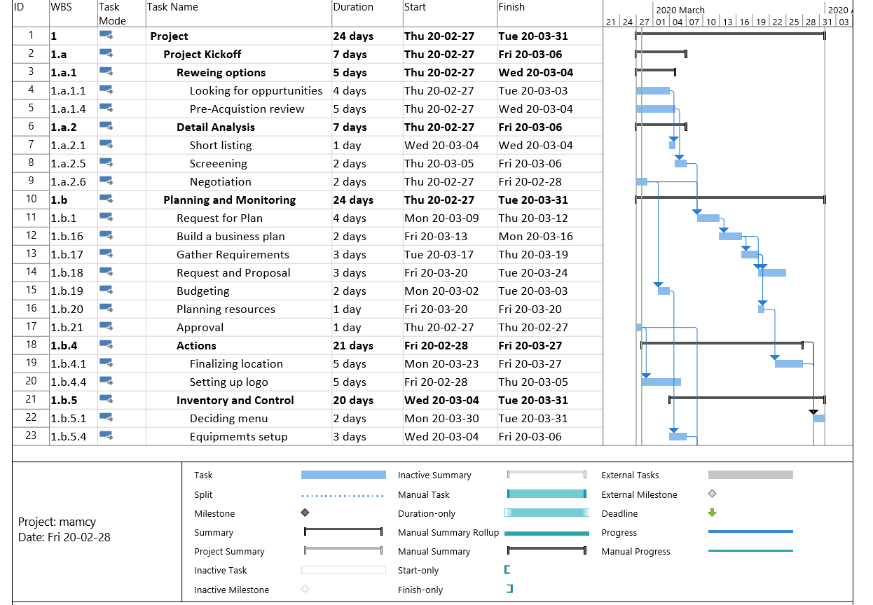

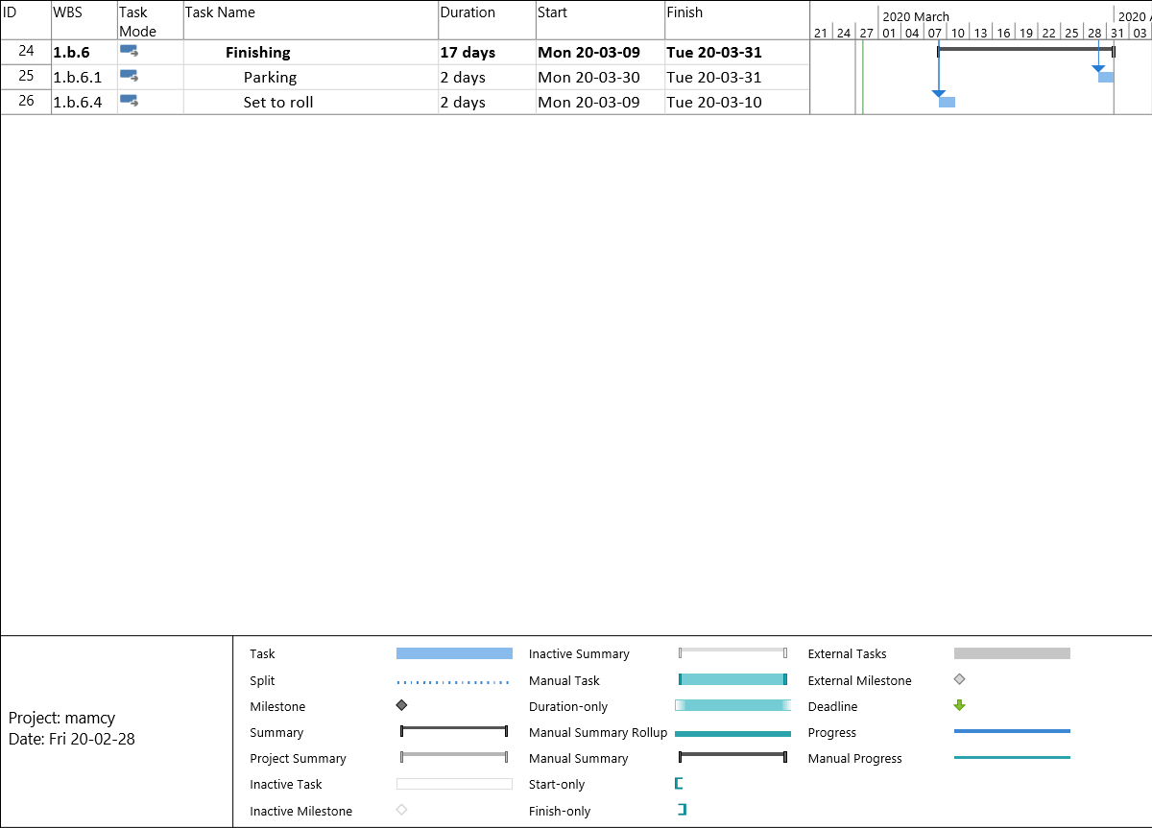

# References for the Data of Merger and Acquisition

*Cost of the Food truck*. (n.d.). Retrieved from Food Truck Empire: https://foodtruckempire.com/how-to/costs/

**2)Sole proprietorship**

Sole proprietorship is an alternative which gives you the profit but the cost of total investment and overall cost for the food truck. The following are variables with respective to sole proprietorship. However, the variables are divided into two categories financial and non-financial variables.

**Purpose: Grow more benefit , increase sales and escalate the brand name**

**Financial Variables:**

Financial variables are usually used to estimate or predict the future economic units because they are the closest indicators which deals with economic entities like investment, profits etc. The list of financial variables we considered to sole proprietorship are as follows.

**1)Investment**: Investment economically means purchase of goods that are not consumed today but they are consumed in the future to create benefits if everything goes according to the plan. Some of the investments to be made are

**2)Training:** Employees need initial training to understand the process and deal with it. Training is considered as a one-time investment.

**3)Purchasing a truck:** Firstly, the initial invest is to purchase a truck which is in good condition and ready to start up a business.

**4)Equipment:** Equipment is also a one-time investment which will be invested at the starting of the business. The equipment includes kitchen utensils and tools which are used to keep the truck going.

**5)Licensing fee:** To engage in a specific line of business the owner of any organisation must pay licensing fee to government authorities. Moreover, this fee is the money which you pay for selling the food with mobility, to roam all over the city freely and make business. From state to city the prices of them vary.

**7)Operating cost:** The money spent to successfully run the food truck in regular basis is simply known as operating cost. Some of the operating costs are as follows. The employee’s salary, gas, rewards, promoting all will be included in this section.

**8)Total Sales:** Total sales are calculated once a year, month, week and day. The total items sold in that particular time frame is calculated as total sales.

**9)Scrape:** Food which is not used to serve is considered as scrape this scrape is obvious in food industry. Total scrape percentage is calculated once in a year. This loss will be divided according to the investment.

**10)Overall Cost:** Money spent on both operating cost and investment is considered as overall cost.

**11)Benefit:** Subtracting the total sales from overall cost gives the benefits.

**Non-Financial Variables:**

**1)Goodwill:** Includes the brand value and reputation of the food truck.

**2)Customer Satisfaction**: The ultimate return which we wanted as a food truck operator is the customer satisfaction. The reviews and feedback can be more helpful to make any modifications.

**3)Innovation:** The creativity in the set up, the method of service, the innovative food ideas can attract people.

**4)Employee Productivity**: The employees play vital role in truck improvement with their efficiency the business can see higher profits.

**How we collected data?**

The four thing techniques we applied for getting our data are:

1)Direct Observation

2)Social Network

3)Google Search

4)Questionnaires

**Data Points**

|  |  |  |  |
| --- | --- | --- | --- |
| **Investment Cost( Month 1)** | | | |
| Item | Estimated Cost | Notes | Data Collection |
| Truck | $25,000 | Average price of an ordinary food truck | Survey |
| Kitchen Equipment | $50,000 | Utensils, Oven, Microwave and Other equipment | <https://foodtruckempire.com/how-to/costs/> |
| Licensing cost | $5,000 | London, Ontario estimates | <https://foodtruckempire.com/how-to/costs/> |
| Kitchen Tables and Chair | $10,000 |  | Assumptions |
| Training | $400 |  | Survey |
| Uniforms and safety gears for workers | $2,000 | For restaurant workers | Assumptions |
| Insurance | $100 | Monthly |
| Other Expenses | $6,000 | remodeling truck | Questionnaires |
| Fire Extinguisher | $200 | safety standard features | Assumptions |
| **Overall Investment Cost (A)** | $98,700 |  |  |

|  |  |  |  |
| --- | --- | --- | --- |
| **Operating cost (Monthly)** | | | |
| Item | Monthly Estimated Cost | Notes | Data Collection |
| Commissary | $400 | This will vary according to the location (any parties, functions, events etc.) | Assumptions |
| Phone / Internet | $120 | for truck purpose | Questionnaires |
| Labor | $3,000 | $14 per/hr. | <https://foodtruckempire.com/how-to/costs/> |
| Repairs | $500 | In case of any breakdowns. | Questionnaires |
| Food / Beverage Restock | $4,000 | Depends on the quantity of the items sold. | Questionnaires |
| Paper Product Restock | $400 | Depends on sale | <https://foodtruckempire.com/how-to/costs/> |
| Parking fee | $700 | Monthly | Questionnaires |
| Register / POS | $100 | Monthly | Questionnaires |
| Paper Products | $20 | Paper towel and napkins | <https://foodtruckempire.com/how-to/costs/> |
| **Total operating cost (B)** | $9,490 |  |  |
| Total Cost = Investment + Operating Cost  = $98700 + $9490  **=$108,190** | | | |
| Profit will be 60-70% and exact will be calculated in cost benefit analysis | | | |

# References for the Sole proprietorship

*Cost of the Food truck*. (n.d.). Retrieved from Food Truck Empire: https://foodtruckempire.com/how-to/costs/

**Gantt Chart**

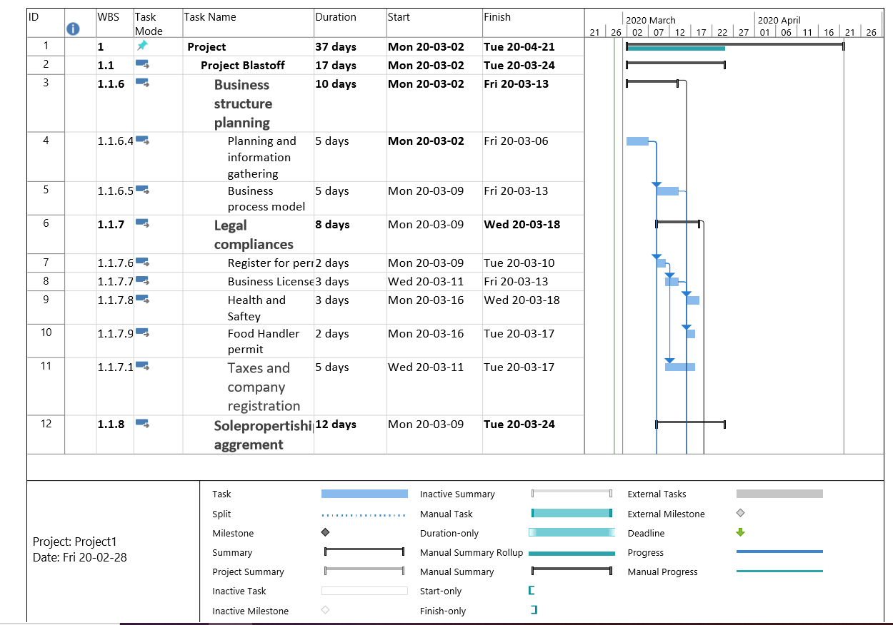

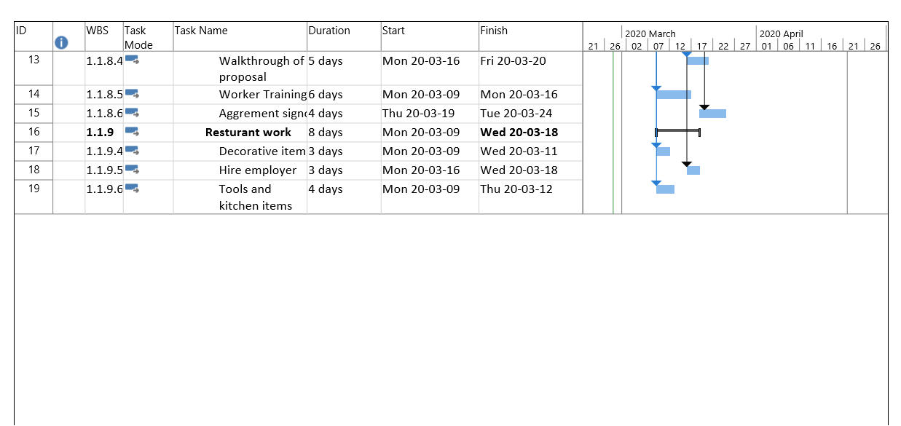

**3)Marketing and Advertisement**

Any marketing plan starts with establishing the overall goals for the business. In this alternative, we are putting more emphasis on promoting the food truck and restaurant “Good for You” because this restaurant has only one location, even though it is an Indian restaurant people are not aware about it. So, the target market for this alternative will be an Indian Cuisine lover with all different age groups.

**Purpose: Build brand awareness, grow market share, increase sales**

Marketing plan consist 4 tactical components (Price, Promotion, Place and Product) to ensure that we put the right product at right place at right price with right promotion, so the customer has the maximum incentive to buy.

Following are the list of variables we will be using to evaluate the solution

|  |  |
| --- | --- |
| **Financial Variable** | **Non-Financial Variable** |
| * Investment | * Goodwill (Brand Awareness) |
| * Operating Cost (advertisement cost, design logo cost, sales promotion expenses, printing cost) | * Customer Satisfaction (customer experience) |
| * Equipment (promoting tools: hoardings, brochures, business cards, newspaper | * Innovation (Ambiance of the food truck) |
| * Margin | * Employee Productivity Rate (quality services and efficiency of the employee) |
| * Overall Cost (Marketing Service expenses) |  |
| * Benefits |  |

following is the matrix for evaluating marketing and advertising alternative including actual and estimation of the existing situation after using this alternative with expected changes.

**Data points**

|  |  |  |  |  |
| --- | --- | --- | --- | --- |
| **Marketing and Advertising Budget** | | | | |
|
| Current Scenario | | | | Future Scenario after promotion |
|  | | | |  |
| Variable Name | | | Amount $ | Amount $ |
| **Financial Variable** | Investment |  | 3500 | 6000 |
| Operating cost | advertisement cost (10%) | 350 | 600 |
| design logo cost (3%) | 105 | 180 |
| sales promotion expenses (10%) | 350 | 600 |
| printing cost (7%) | 245 | 420 |
| **Total Operating Cost (30%)** | **1050** | **1800** |
| Equipment | Social Media Marketing | 0 | 0 |
| hoardings (6%) | 210 | 360 |
| brochures (7%) | 245 | 420 |
| business cards (5%) | 175 | 300 |
| news paper (2%) | 70 | 120 |
| **Total Equipment Cost (20%)** | **700** | **1200** |
| Training | Marketing Training (10%) | 350 | 600 |
| Loyalty Program (10%) | 350 | 600 |
| **Total Training cost (20%)** | **700** | **1200** |
| **Margin** |  | **3%** | **6%** |
| **Overall Cost** |  | **3500** | **6000** |
| **Benefits** |  | **105** | **360** |
| **Nonfinancial Variable** | Goodwill | 5% | 175 | 300 |
| Public relations | 5% | 175 | 300 |
| Customer Satisfaction | Currently reviews are 4.1/5 | 82% | expecting 90-95% |
| Innovation |  | 5% | Expecting to increase to 10% |
| Employee productivity rate |  | 5% | expecting 7-10% |
|  |  |  |

**How We Collected Data?**

* Interview with the owner
* Online research
* Samples of food truck business plan
* Statistics on food industry
* Questionnaire

**Gantt Chart**

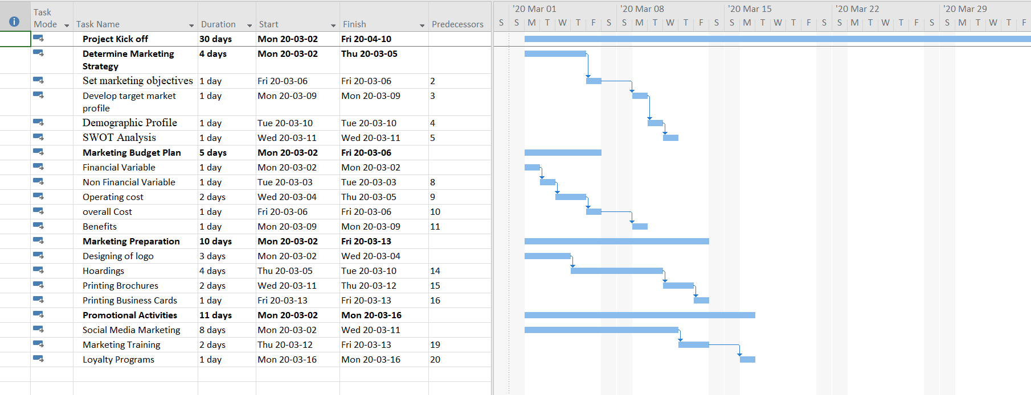

**Data Citation**

Most of the data is assumed based on the following information

1. While doing interview with the owner and asking him the approximate expenses
2. While doing research online, I have found that the profit margin for restaurant is 3% whereas food truck has 6-9%. Which means, food truck business has better growth opportunities than restaurants.
3. Restaurant Industry 2020
4. Diner, N. M. (n.d.). *Restaurant Marketing Plan.* Retrieved from MPlans : https://www.mplans.com/restaurant_marketing_plan/critical_numbers_fc.php